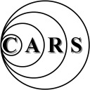
Chelmsford Amateur Radio Society
Established 1936
Affiliated to the RSGB Club Call Sign-G0MWT
President-Carl Thomson, G3PEM Chairman-John Yates, G1UZD
Treasurer-Brian Thwaites G3CVI Acting Vice Chairman-Geoff Mills, G3EDM
Newsletter No 583 Web Address: www.g0mwt.org.uk October 2014

This Month’s Meeting
OAKLANDS MUSEUM, MOULSHAM STREET, CHELMSFORD, CM2 9AQ
Tuesday 7th October, Annual General Meeting.

This Month’s Meeting –at 7.30pm at the Oaklands Museum, Moulsham Street, Chelmsford Another year has gone by and it is time for another CARS Annual General Meeting. This is the time to have your say and to tell the new Committee what YOU would like to hear/see/do during 2014 to 2015. If you can give some time to help CARS by operating radio or by assistance in running the club it would be very much appreciated. See the website for instructions for nominations. Don't just sit back and let the same people do the work. A club is only as good as its members. The agenda is also on our website at www.g0mwt.org.uk.

Note that Murray Niman, G6JYB is giving a talk on OFCOM's proposals for changes to the amateur radio licence after the AGM business is over. Don't miss it!

Dates for your Diary
Tues 14th, 21st, 28th | CARS - Evening Radio Nets @ 8:00 pm (Local). See Website for details.
Every Monday | Essex Ham 2m Net @ 2000h GB3DA
Tuesday 7th October | Annual General Meeting, Agenda on the Website
Thursday 16th October | Essex Repeater Group AGM Danbury Village Hall 1930h for 2000h
Monday 20th October | Cars Skills Night 7:00 pm Danbury Village Hall
Thursday 30th October | Advanced Revision Course @ Danbury Village Hall
Tuesday 4th November | Essex RAYNET by Roland Taylor, M0BDB @ Oaklands Museum
Monday, 17th November | Cars Skills Night 7:00 pm Danbury Village Hall

To remain a Member of CARS or join as a new member, send a Cheque for £15 Payee CARS (with a SAE to allow for the return of a valid membership receipt) to our new membership secretary.

Mr James D Beatwell 36 Hunts close Writtle Chelmsford CM1 3HJ

Adult Membership (16s and under are FREE) to:-

Nets Tuesdays 2000h (14th) GB3DA, (21st) GB3ER, (28th) 1.947MHz

Also there is the Essex Ham net every Monday @ 2000h on GB3DA

Net Controller for October is Colin, G0TRM Thanks to Carl, G3PEM for September.

Erratum Constructors Contest results

Second Prize - Andy, G1GKN - 470kHz Transverter
Third Prize - Charlie, M0PZT - Logging Tablet..

Not as originally published in the September edition as these were inadvertently transposed.

"D Star Radio Operation and Demonstration" By Joel, G0URK and Gary, 2E0ULA.

September's meeting saw Gary 2E0ULA, with assistance from Joel G0URK, enlighten us about the D-STAR mode. It's a digital system that typically uses an Icom transceiver to communicate with other D-STAR users. There is a network of digital gateways and repeaters which allow you to speak not just locally via RF, but to "conferences" from all parts of the World just as if it were a local QSO on 2m FM.

One of the benefits of D-STAR is the size of the transmission, just 6.25KHz of spectrum is required compared to the usual 12.5KHz of an analogue FM transmission.

One of the downsides is that the radios are not cheap: Expect to pay around £400 for a 2m/70cm FM/D-STAR handheld! Thanks to Gary and Joel for their informative talk and demonstration of the D-STAR technology. The now famous CARS Raffle was run by James 2E1GUA and Carl G3PEM with refreshments courtesy of David G3SVI and Myra M0MYR.

Report by Charlie Davy, M0PZT
______________________________________________________________
Cathy M0RTW heads to Antarctica

In October Cathy Colless M0RTW will travel to Antarctica to take up the post of Radio Communications Officer at the Rothera Research Station.

CARS members will know Cathy from the Foundation and Advanced courses as well as the CARS Skill Workshops at Danbury Village Hall.

In 2013 Cathy, took and passed, all three amateur radio licence levels in just 57 days with no prior amateur radio experience.
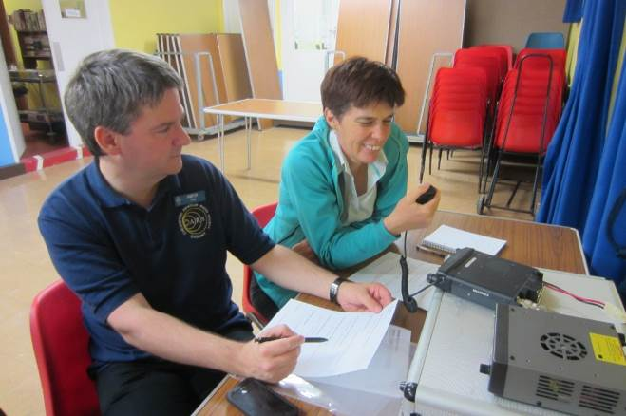
Peter Sipple M0PSX teaching Cathy Colless now M0RTW at the CARS Foundation course
She did the Foundation course and exam with the Chelmsford Amateur Radio Society (CARS) in October 2013, and whilst attending the CARS Advanced course in November, took her Intermediate exam with the Bromley and District Amateur Radio Society. With the Intermediate successfully under her belt, she was able to sit the Advanced exam session with CARS on December 6, 2013 and became the holder of M0RTW.

Cathy said: “The training team at CARS were consistently generous, patient, friendly and knowledgeable. The training was well planned and paced and very carefully prepared, and the team was very supportive, with encouragement such as “we’ve all been where you are now… Don’t worry, the penny will drop…don’t give up!” I owe the team at CARS a big thank you for all their help and support.”

“The Advanced exam in December was tough and I was shocked when I passed it (with merit to boot). It just goes to show what a good job the CARS training team did.”

Cathy has started a blog that will detail her experiences in this opportunity of a life-time, follow it at http://passyourmessage.com/

She leaves the UK to travel to Antarctica via Punta Arenas in Chile on October 19.
______________________________________________________________
"Trouble at the Mill"

Although operating from the home Shack can pose its problems (XYL, kids, neighbours etc), Sandford Mill also offers-up some interesting "issues"! The power-cut which affected one of our Sunday sessions on 40m was a classic - The day was saved due to the intervention of the ever-prepared G8DET who asked me to help him retrieve a generator from the depths of his garage (quote: "30 years of tat"!).

Our most recent outing at the Mill on 11+12th September were not without, ahem, problems. First was the solar-flare that decided to give frequencies above 10MHz a considerable thrashing. Andrew G0IBN (usually a cheerful chappy) came sulking into the Hut from upstairs asking us to check how 20m sounded on the Doublet. "Not good, a bit meh" was my technical offering so the decision was made to end the CW fun for the day. As for us down in the Hut on 40m, it was solid inter-G and the odd DL/PA for much of the day.

Friday presented us with the opportunity of a quiet upstairs office, a 20m Delta-Loop, kettle and a window but no radio kit. So, along came my FT-857 and laptop with the aim to try some PSK/RTTY. After confirming that there was an SGC "smart-tuner" on the roof that just a few watts of RF were needed to auto-tune on any band, I arrived for 10am on the Friday only to find that the radio didn't like the aerial on any band from 7MHz to 30MHz. Yes, I turned everything off-and-on-again but still the SWR meter was grumbling at me.

A phone-call to Tony G4YTG ensured that CARS "Aerial International Rescue" was on-site 20-minutes later. After venturing up the hatch and onto the roof, my radio started to make some noises as if an aerial were connected to it and after Tony shouted "try that", all was well and the aerial quickly tuned onto any band within half a second of RF leaving the radio. The 1st QSO was on 10m RTTY running 50w which yielded T6T in Afghanistan.

So, while James 2E1GUA and John G1UZD got on with the 40m station, I had a nice run of QSOs on 20m, 17m and 15m. A total of 22 Countries/DXCC were logged and aside from that 10m contact, all the others were made with just 35watts. PSK is a great mode for low-power and, like CW, often makes the trip when SSB won't. Hopefully we can showcase digital modes during "Science Discovery Day" and offer a visual attraction for visitors and explain how computers, digital signals and relatively low-power can be used for efficient communications.

If you've never tried using a digital mode like PSK or RTTY - the software that many Hams use is "Ham Radio Deluxe" which is what we use for logging in the 2MT Hut. The software incorporates a variety of digital modes but there are other programs out there like Digipan, MixW and my own creation: PZTLog which I was using. The inferface that connects your computer's soundcard to the radio's "data" port is a simple audio isolator and PTT control. Off-the-shelf solutions can be purchased from Radio Arena or G4ZLP for £25. The Signalink-USB is also a popular (if a little pricey) alternative.

There are some great "primers" for getting started with datamodes, such as this set of "Top 10 PSK Tips" from 2E0JCQ: http://www.randomizethis.co.uk/top-10-psk31-tips-for-beginners and Pete M0PSX has wrote a "Getting Started" guide on his Essex Ham site: http://www.essexham.co.uk/how-to-get-started-with-data-modes

I suppose it would be fitting to plug the Skills Workshop as the place to find out more and see datamodes in action - Whether you're shopping for an interface, confused with software settings or even where to call "CQ" - Somebody will be able to help.

Charlie - M0PZT
______________________________________________________________
Sandford Mill 24th August.

On Sunday the 24th August the old Marconi hut from the Writtle site was given over to the T1154 and R1155 to demonstrate and operate on the 80 metre AM frequency. The transmitter, made in 1944, plus linear amplifier produced an output of 100 Watts AM producing an excellent AM signal despite the lack lustre band conditions.

Contacts were made across the UK including PA/G0TBI (Stuart) who was operating from Scheveningen Harbour in The Hague. The most outstanding signal was that received from Steve G7KLJ from Ashford whose awe inspiring BBC quality audio with a silent background held both spectators and operators spellbound. A most interesting contact was made with another T1154/R1155 station at the Yorkshire Air Museum.

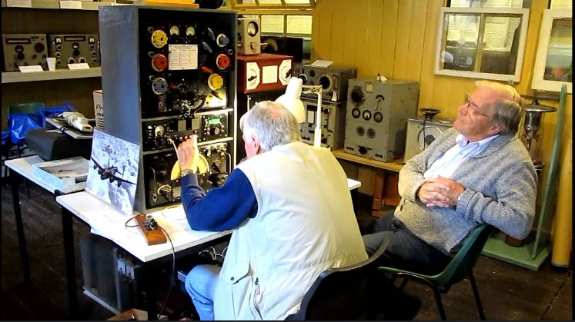
John G1UZD operating the T1154/R1155

There was constant stream of visitors to the hut and the CARS team responded to many questions about the radio, the aircraft and Marconi. It was altogether a useful and productive day.
______________________________________________________________
Making Waves: How Marconi’s Wireless Legacy Takes Us Ever Further Into Space

WHEN: Wed 29th Oct, 7.30pm-9pm
WHERE: Anglia Ruskin University
HOST: Chris Neale, Chelmsford Science and Engineering Society

The Grandson of Guglielmo Marconi will talk about his Grandfather’s early history and how his development of wireless technology impacted on space research. Professor Parasce Marconi is an experimental astrophysicist. He has an undergraduate degree in physics from the University of Rome and a PhD from the University of California, Berkley. His areas of expertise are advanced instrumentation and star formation. He has worked for NASA, ESA and ESO and is currently senior astronomer at the National Institute of Astrophysics in Rome.

Organised by Chelmsford Science and Engineering Society as a special event for the Chelmsford Ideas Festival.

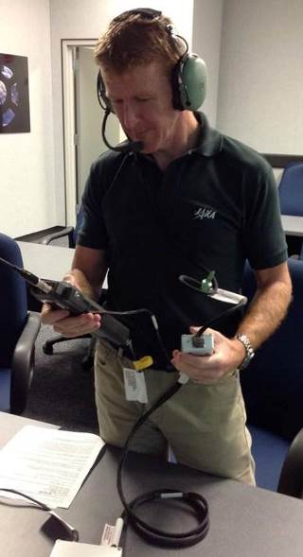
You do not have to be a scientist or engineer to enjoy this very relevant family story and its importance to Chelmsford!

Booking required: www.anglia.ac.uk/community or call 01245 684723.
http://www.changingchelmsford.org/if2014/
______________________________________________________________
UK Astronauts Heading to Space Station

In May 1991 the first UK astronaut Helen Sharman GB1MIR talked to radio amateurs around the world from the Mir space station. After a gap of 24 years it looks as though two more UK astronauts will be flying to the International Space Station (ISS) in 2015.
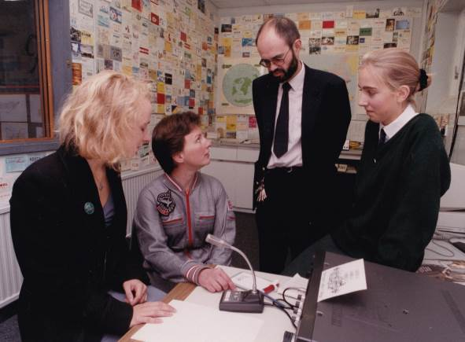
Anna-Karin G7IRR Helen Sharman GB1MIR Richard Horton G3XWH Katy G7NST at a visit Helen made after her mission to the Harrogate Ladies’ College

One of the UK radio amateurs that Helen contacted all those years ago was Chris Lorek G4HCL he says: I remember it fondly! I and my three children all chatted with her on 2m using my club station call G4SMC (South Midlands Communications in Chandler’s Ford) on her next-but-last Mir pass over the UK before she came down. Steven (10 years old), David (8 years old) and Carolyn (5 years old) all said hello to her, each giving their name and age, with Steven asking whether there was a particular challenge she may have had. Helen replied, knowing it was very young children, that one difficult challenge she’d had was putting her socks on as she floated around the station!

In September 2015 Sarah Brightman hopes to become the 2nd UK astronaut when she flies to the ISS on a 10 day mission. She is committed to encouraging young women to pursue careers in Science, Technology, Engineering, and Mathematics. In 2012 in conjunction with Virgin Galactic, she launched The Brightman STEM Scholarship program. It is not yet clear if she will operate the ISS amateur radio station during her mission.

Tim Peake was selected to train as an astronaut in 2009 and hopes to go to the ISS in November 2015. He holds the USA callsign KG5BVI and has recently been learning to use the Ericsson 144 MHz handheld radio which is installed in the Columbus module of the ISS. On September 18 Tim said "Will be great to chat with schools next year from space using this ham radio on board the ISS."
Tim Peake KG5BVI learning the controls of the ISS amateur radio station equipment

There are two amateur radio stations on the ISS, one in the Russian Service Module, the other in the ESA Columbus Module. Almost any 144 MHz FM rig will receive signals from the stations, you can even use a general coverage VHF scanner with an external antenna. As far as the antenna is concerned the simpler the better. My favourite is a ¼ wave ground plane as it has a high angle of radiation. I’ve found large 2m colinears don’t work quite as well since the radiation pattern is concentrated at the horizon.

You can receive the ISS outdoors using a 2 metre hand-held with its helical antenna but a 1/4 wave whip will give far better results.

In the UK we use narrow 2.5 kHz deviation FM but the ISS transmits using the wider 5 kHz deviation used in much of the world. Most rigs can be switched been wide and narrow deviation filters so select the wider deviation. Hand-held rigs all seem to have a single wide filter fitted as standard.

Voice contacts with astronauts usually take place using "split" frequencies. The astronauts transmit on 145.800 MHz and listen for replies on 145.200 MHz, you just need to activate your rig's repeater shift. Recently, however, they have also been listening on 145.800 MHz.

When astronauts are not on the air they usually leave the packet digi-peater running on 145.825 MHz so why not listen out for it.

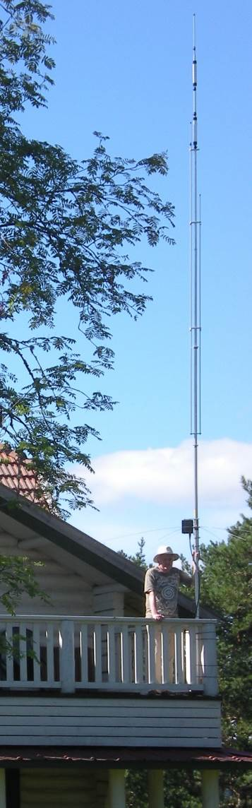
ISS status and tracking information
http://issfanclub.com/

The First UK Astronaut Helen Sharman GB1MIR
http://amsat-uk.org/about/history/first-uk-astronaut-helen-sharman-gb1mir/

Sarah Brightman to fly to ISS
http://amsat-uk.org/2014/09/04/sarah-brightman-to-start-space-flight-training-in-january/
______________________________________________________________
Operating from Finland
One of the problems when operating abroad is getting your gear there. An obvious solution is to go by car if the QTH is not too far away. This is what I have done for some 15 years when operating from Sammatti in south west Finland, locator KP10vh. I choose to take a linear amplifier with me which weighs 20kg so what with the other equipment, to go by air is inconvenient although somewhat cheaper. I have a Finnish wife and I operate from her family's summer house set in a forest by a large lake and well away from neighbours. As a result the location is RF-wise very quiet.

It doesn't take long to set up the station as the Cushcraft R6000 vertical antenna is stored at the summer house and already assembled albeit in 3 sections which push together and then tightened with jubilee clips.
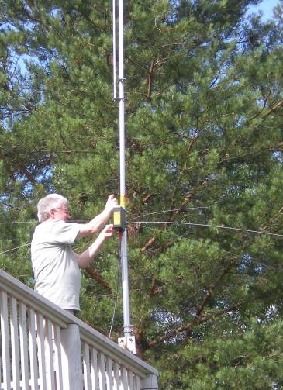
The R6000 is mounted on a 5 feet long pole held into the corner post of an upper floor balcony corner by large Ty-wraps. This puts the antenna into the clear and above the roof line. I also keep a 30A linear power supply at the summer house as well as feeder, power leads, some tools and other odds and ends. Conveniently there is a 3 phase socket and 2 single phase sockets available. I am currently using an Icom IC-7000 to drive the linear both of which travel with me. The matching of the R6000 is excellent on all the 6 bands it covers (20m to 6m) so the internal AMU in the linear, an SPE Expert 1K-FA, is only used when it's raining as the match changes. There were several thunderstorms due to the exceptionally hot weather - up to 32.5C.
It pays to assemble the antenna exactly as the instructions say regarding dimensions. The only adjustment post assembly was the 20m top section to get it to resonate in the desired section of the band. This year I had 350 QSOs with all parts of the world and thoroughly enjoyed myself.
I would like to thank the dozen or so CARS members who contacted me during this year's stay, some more than once. The short skip conditions on 20m to the east of England were very good for most of the time so making QSOs very easy. I run the linear in half-power mode at 500 Watts for all except the really difficult QSOs when I can then run up to 1kW which is allowed in Finland.

Remember that operating from abroad is open only to full licence holders so this could be another reason to take advantage of CARS training courses to get a full licence.

John OH/G1UZD 
______________________________________________________________
Proposed changes to Amateur Licences

After the AGM, the CARS meeting will have an extra feature.

As recently appointed RSGB Spectrum Chairman, Murray G6JYB is in a position to give attendees an overview and pointers to quite a complex Ofcom 35 page consultation on the proposals to change amateur licences.

Sandford Mill - Science Discovery Day - Sunday 28th September

This is Sandford Mill's major annual science event. A chance for all the family to try out hands on science activities and find out about Chelmsford's industrial heritage.
Also including:
- Live transmissions by Chelmsford Amateur Radio Society using the call sign GB100MWT
- The Great Train Show
- Interact with programmable toys and vehicles – talks, demonstrations and a chance to build a vehicle
- Displays and demonstrations from Essex University
- Steam train rides

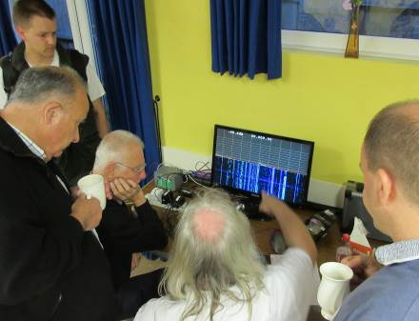
Sandford Mill will be open to the Public from 10 to 5pm. This is a very different event to the other open days.

FREE to park, FREE to enter and FREE to get involved with the many activities Dr Bowles and his team will be putting on. Light refreshments will also be available.

CARS will be operating from the Marconi Hut for typically the last operating outing of the year until International Marconi Day in April 2015.

CARS needs your support. We have a good rig, good aerial and a good QTH - please come and use it to call the world and demonstrate to the public that Cellnet phones are not the only way of communicating. Please don't leave it to the same handful of operators. See you there?

John G1UZD
______________________________________________________________
Presidential Jottings

. Last month’s meeting was an excellent example of how the convergence between radio and computing has taken place. I recall a lot of various technical discussions during the 1970’s and 80’s taking place on the possibilities of merging the two branches of electronics. My opinion is that the demonstration of D-Star to the public, particular to the younger element should encourage them to give our hobby a try.

Our next meeting is the AGM and presentation of awards and therefore I would urge all members to come along and support the Chairman and committee.

Brian G3CVI is standing down as Treasurer after 25 years and of behalf of CARS membership I would say a very big thank for all the work carried out on behalf of CARS.

Carl, G3PEM
CARS September Skills Night

Monday the 15th of September was another busy Skills Night for CARS. 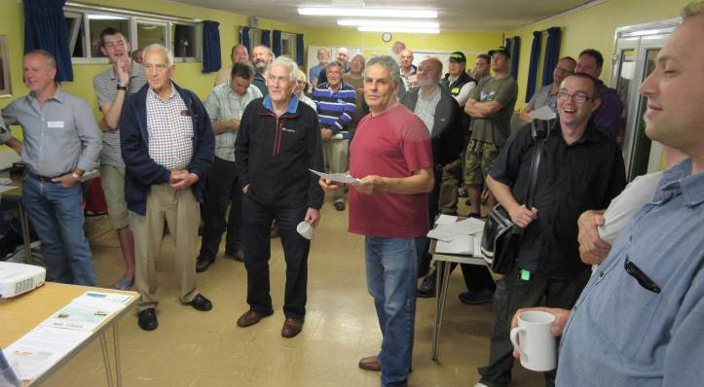Almost 50 attendees gathered for a good mix of demonstrations, show-and-tell, chat and tea.

This month, the activities included a demonstration by Peter G0DZB of a Raspberry Pi being used to show the signal spectrum of the 40m band, a hands-on session with the Flex 1500 SDR courtesy of Richard M0CLZ, data modes explained by Charlie M0PZT and satellites with Steve M0SHQ. Other highlights included Rob M0KCP running a live CW station, the quiz hosted by Clive G1EUC, Jim 2E0RMI in the “Newbies Corner” helping out with questions, plus Peter M0PSD and Chris G0IPU busy in the construction corner. Also back by popular demand, Jim 2E0JTW making callsign badges while-you-wait.

Thanks to all of the CARS members who helped out, including Dave G3SVI, Myra M0MYR, Ann (Mrs 2E0RMI) and Sarah M6PSK for the behind-the-scenes help.

The next CARS Skills Night is on Monday the 20th of October, and you can sign up for email updates at www.hamskills.co.uk Pete M0PSX
______________________________________________________________
Offered free

2m. HB9CV 2-element and a 2m. cubical quad antenna (both hardly used/indoors only) FREE to a good home, Collect from Ingatestone.
Contact Peter Home at phome@btinternet.com
______________________________________________________________
 If you would like a follow up article on John’s travel details in next month’s newsletter please let me know via cars.editor1@gmail.com
______________________________________________________________

Closing date for items in the next Newsletter – Wednesday 24th October.

